**Final Operations and Assembly Manual**

**ME 486C - FanFlyer**

**Faculty Advisor: Dr. Trevas**

**Technical Advisor: Brandon Begay**

**Client: Jim Corning**

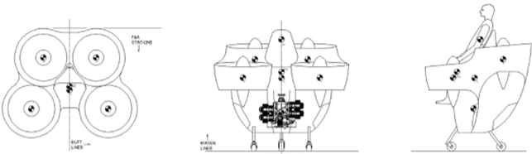

Fan Flyer team members

Steve Sorden

Travis Byakeddy

Corey Marcum

Nathaniel Schaul

Material-

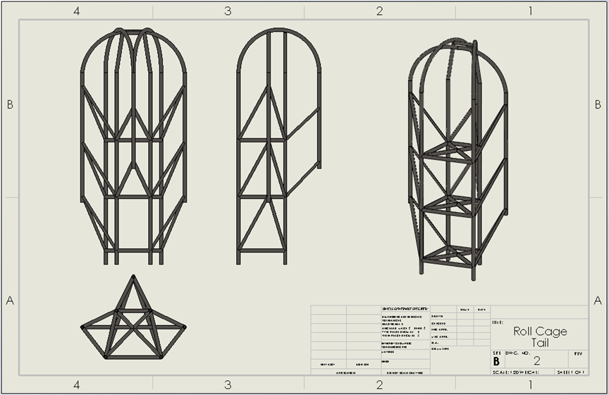

**Figure 1:** Team’s Final Design Concept

The above frame is the final design that the team proposed to the client to use in the fanfler design. The frame is estimated to weigh approximately 84 lbs using the client suggested 4130 steel, which can be verified by the solidworks analysis of the frame seen below in Figure 2.There are no specific steps in order to create the frame. The frame is required to be custom made to fit the fanflyer shell. There are, however, general steps and approximate material values that will be discussed.

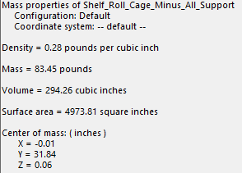

**Figure 2:** Dimensions and Specs of Final Frame

The approximate values for the 4130 steel tubing should be as follows: tubing should be 1.5 inch OD (Outside Diameter) and 1.375 ID (Inside Diameter). The approximate length of material required to complete the final frame is ~ 80 ft. The first step would be to cut all lengths of members in the structure. Each member will be notched in order to fit the saddle of the tube flush to the side of another piece of tube so that they can be welded together. Figure 3 and Figure 4 shows the saddle of a notched tube and a tube notching device respectively. Additionally, the frame manufacturer will need to implement the use of a tube bending machine to get the required radius necessary for the roll cage of the frame design.

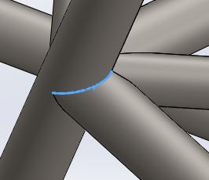

**Figure 3:** Highlighted Notched Saddle

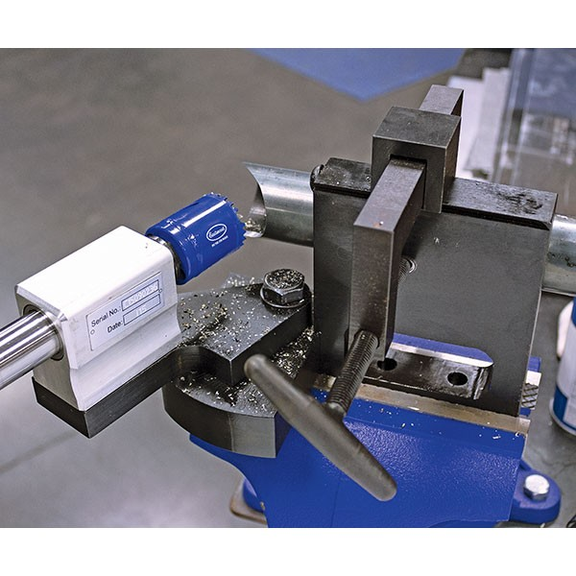

**Figure 4:** Tube Notching Machine []

Welding-

The client has requested that the frame be welded as the frame will be subjected to in-flight stresses and vibrations that would be handled far better by a solid welded frame versus a frame assembled by mechanical fasteners. The client wishes to build the frame from an aircraft 4130 steel material; however, the team has suggested that the frame would perform better if it were built using aircraft aluminum. There are varying types of aluminum that will be considered. The difference in welding steel and aluminum are large, there is even a big discrepancy between welding the different types of aluminum. Below the team will address the processes of welding differing materials.

**4130 Steel -**

Steel is a straightforward weldment that can be welded easily without issues as long as certain guidelines are met. 4130 Steel is a chromoly alloy steel that combines the use of chromium and molybdenum.[2] The steel offers a high carbon content which reduces weldability compared to low carbon steels, yet aids in strength to weight ratios. 4130 steel requires preheating the material to 400-500F for thickness of up to ½ inch.[2] The form of welding required for steel is very lenient. Steel can be welded using GMAW( Gas Metal Arc Welding) also known as MIG, GTAW (Gas Tungsten Arc Welding) or TIG, and FCAW( Flux Cored Arc Welding). Lastly the weld must be allowed to cool slowly to reduce embrittlement.[2]

**Aluminums:**

Despite the clients disinterest in using aluminum in the Fanflyer frame at this stage, the team believes it is an important material to consider in future models of the manned quadcopter. Aluminum can be a trickier material to weld compared to steel it comes down to the Aluminum alloy type. Alloys that are weldable start with 1,3,4,5, or 6. Therefore, 6061 T6 Aluminum would be an acceptable material that can be welded. The alloy types that are notoriously considered to be “non weldable” start with a 2 or a 7; however, advancement have been made that we will discuss.

6061 T6 Aluminum-

There are many advantages to welding aluminum. It offers a high strength of welded joint, it is ductile which aids in fatigue or shock loading, and has corrosion resistance properties which allows the material to be exposed to salty climates. The process for welding 6061 T6 Aluminum is in some ways similar to welding steel but requires a different form of welding. The type of welding that is required is GTAW(Gas Tungsten Arc Welding) also known as TIG (tungsten inert gas) which uses low-hydrogen electrodes to minimize diffusible hydrogen within the weld to reduce air pockets and cracking. Additionally, compared to welding steel, aluminum has to undergo a post-welding heat treatment process. [3]

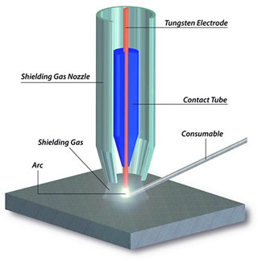

**Figure 5**: GTAW Nozzle Diagram [4]

7075 T6 ALuminum-

This type of aluminum was one of the alloys previously considered to be “non weldable”; However, there has been recent advancement in the technology that is being worked on by a lab at the University of California Los Angeles (UCLA). The team has developed a breakthrough welding wire that infuses titanium carbide nanoparticles to aid in the welding process.[5] This is a huge advancement because 7075 aluminum is approximately ⅓ the weight of steel but allows for similar or better strength in material. Although this material is not commercially available to be welded it is important to keep an eye on it for future renditions of the fanflyer.

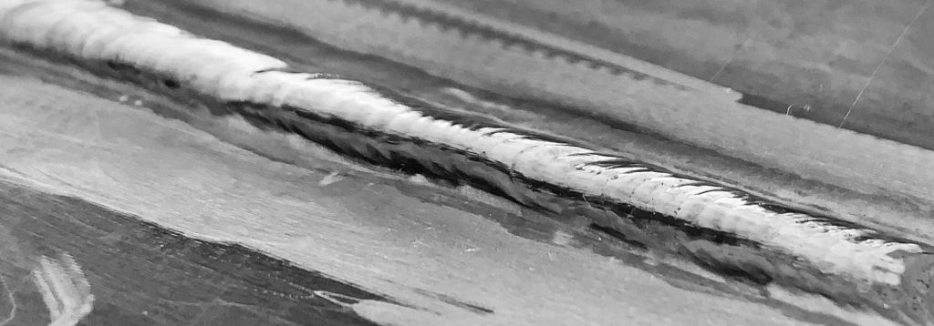

**Figure 6:** Weld of 7075 T6 Aluminum Using UCLA Welding Wire

Connection to Shell

The client plans to connect the frame to the shell using six different locations around the rotors. The connection points can be seen in Figure 7. The brackets, shown as the blue lines in the figure, will be attached to the shell of the Flyer and then welded to the six connection points of the team’s frame. These connection points are the blue circles at the ends and in between the brackets. The client has also asked for the team to add a support for a ballistics safety parachute system. This frame point exists at the back of the flyer and will also have a welded connection point to the frame.

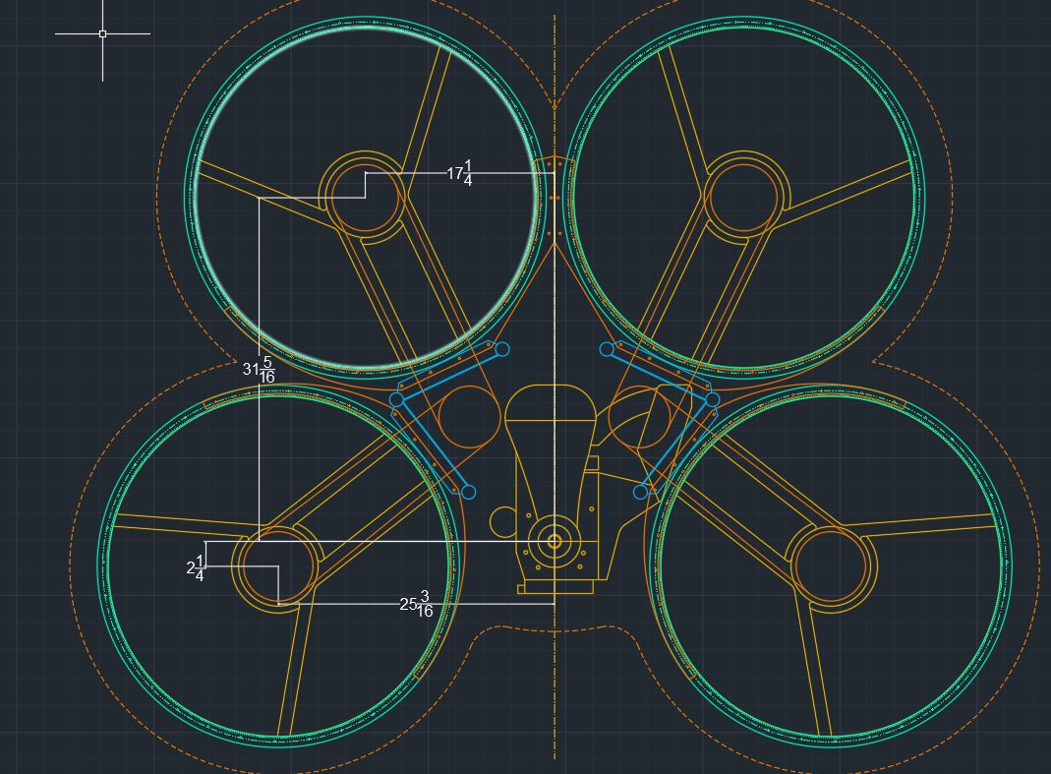

**Figure 7:** Frame Connection Points

References-

|  |
| --- |
| [1] Eastwood, "Eastwood Professional Tubing Notcher," Eastwood, [Online]. Available: https://www.eastwood.com/professional-tubing-notcher.html. [Accessed 29 April 2019].  [2] "How to Weld 4140 Steel," Welding Answers, 23 Novemeber 2015. [Online]. Available: http://weldinganswers.com/how-to-weld-4140-steel/. [Accessed 29 April 2019].  [3] Miller, "How a TIG Welder Works and When to TIG Weld," Miller, 2007. [Online]. Available: https://www.millerwelds.com/resources/article-library/tig-it-how-a-tig-welder-works-and-when-to-tig-weld. [Accessed 29 April 2019].  [4] anilkumarzone, "Tungsten Inert Gas Welding (TIG)," Father of All Fields: Mechanical Info, [Online]. Available: https://mechanicalinfo.wordpress.com/tag/gtaw/. [Accessed 29 April 2019].  [5] J. Huetter, "UCLA team develops new wire to weld 7075 aluminum," Repairer Driven News, 26 February 2019. [Online]. Available: https://www.repairerdrivennews.com/2019/02/26/ucla-team-develops-new-wire-to-weld-7075-aluminum/. [Accessed 29 April 2019]. |